**1.INTRODUCTION**

|  |
| --- |
| Software Requirements Specification  forr  Machine Learning in Diabetes  Version 1.0  Prepared by  U.Mershika |

**Document Purpose:** To detect if the person is suffering from diabetes using glucose and blood pressure as features and Diabetes as label.

**Product Scope :** Helps to check if a person has diabetics

**Intended Audience:** Developer, Tester

**2.Overall Description**

**Product Overview:**

**Product Functionality:**

R1: Download data in CSV format

R2: Using pandas extract features and label from CSV file

R3: Build ML Model using ML Algorithm

R4: Predict and analyze

**3.Functional Requirements:**

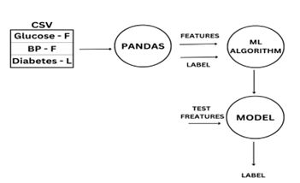

Using pandas extract features and label from CSV file

Build ML Model using ML Algorithm

**4.Other Requirements:** N/A